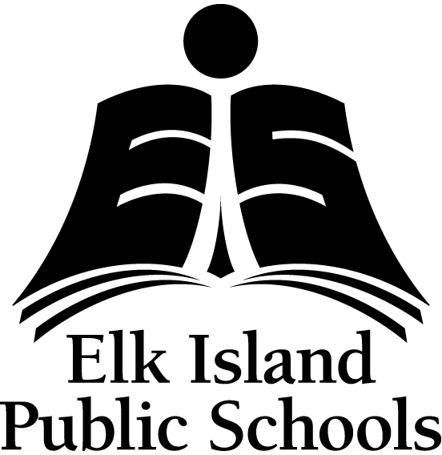
CHILD/STUDENT MEDICATION/PERSONAL CARE MANAGEMENT PARENT/GUARDIAN CONSENT

AP 315 Medication/Personal Care

Child/Student Name

Approval
I request that

(School Name)
staff administer/monitor my child's medication as outlined in the attached Child/Student Medication Management Plan and/or the Student Personal Care Management Plan for my child. I make this request in the knowledge that school personnel may have no special training or limited training in the administration of the medication/personal care. I must inform the principal/designate of any changes in the administration of the medication/personal care and a new Child/Student Medication Management Plan and/or Child/Student Personal Care Management Plan form must be completed.
I will give the schools the physician prescribed medication in its original container with the current pharmacy label attached. The medication dose schedule has been planned such that a minimum number of doses will be give at school. Medication/Personal Care supplies and refills will be supplied to the school when necessary.
I accept responsibility to ensure the safe transportation of medications/personal care supplies to the school. I hereby acknowledge that the principal/designate has been authorized to administer the prescribed medication/personal care and I hereby release the principal/designate and Elk Island Public Schools from any claim for harmful effects resulting from the administration of the prescribed medication/personal care. I hereby agree to indemnify and save harmless the principal/designate and Elk Island Public Schools from all claims that may result.

Parent/Guardian Name (Print) Parent/Guardian Signature Date

Principal/Designate Signature Date

Freedom of Information and Protection of Privacy - Sec. 33/34
The information collected on this form is for the purpose of administering medication/personal care arrangements for your child/student. This personal information is collected pursuant to the provisions of the School Act and Regulations thereto, and the FOIP Act. If you have any questions about the collection and use of the information, please contact the principal of the school or the Associate Superintendent, Instructional Services, Elk Island Public Schools, Sherwood Park, Alberta, at 780-417-8227.

Revised Oct 26/12
www.eips.ca
Pg 1 of 1

