December 10, 2024

Dear Parents/Guardians:

As an extension of our Physical Education curriculum, all students in grades 4 to 6 are being offered the opportunity to go skiing or snowboarding at Sunridge Ski Hill on Friday January 10, 2025. We will leave the school at 8:45 am and arrive at the hill around 9:00 am. Students will ski until 2:00 pm. We will depart from Sunridge Ski Hill at 2:30 pm for the bus trip back to the school, arriving at approximately 2:45 pm. Students and staff will be transported to and from the hill via school bus.

The permission form has been sent out through Permission Click, and fees are to be paid through PowerSchool.

Prices for the ski trip are:
Lift ticket, lesson, rental - $51
Lift ticket, lesson - $35.50
Season pass holder - $23.50 (this is for the lesson)

If students are bringing their own equipment, they are not permitted to transport their equipment on the school bus. Equipment can be brought to school on the morning of the ski trip. Please leave the equipment by the grade six doors to be loaded into a designated vehicle that will transport the equipment to the ski hill.

Staff members and parent volunteers will supervise students. The safety guidelines for physical activity in Alberta schools will be met. Students will review the safety policies and procedures encountered at Sunridge Ski Hill. There is a first aid station located on the hill, as well as a ski patrol. Students are encouraged to ski and stay in groups of two or three. Staff and parent volunteers will be on the hill or in the chalet and will have prearranged check-in times and locations with students. Students are instructed to stay within bounds and follow all site rules and safety procedures. Students will be required to follow all applicable school and school bus rules for the duration of the trip.

Students are to bring a large, bagged lunch with items that do not require microwaving. Students may also bring money to order hot food from the cafeteria.

We encourage parents to come and enjoy this day of skiing with their kids. Parents that would like to ski with their child can pay for their rentals and lift passes at the hill on the day of the field trip. Please email Scarlett Miller (scarlett.miller@eips.ca) if you would like to volunteer. The hill supplies us with a few free volunteer passes. Please let me know if this is something that would interest you.

A Few Reminders:
- Complete the permission form on Permission Click
- Pay for Ski Trip on PowerSchool no later than January 6, 2025
- Please note that January 10th is an instructional day, so teachers will leave work for the students that stay at the school
- If your student is not attending the ski trip or school, please advise the office ASAP
We are looking forward to the ski trip, and we can’t wait to spend the day outside being active! Please complete the attached form and return it to your classroom teacher ASAP. If you have any questions or concerns, please contact Scarlett Miller scarlett.miller@eips.ca

Sincerely,

Scarlett Miller

Information for the Classroom Teacher - Please complete the form and return it on December 16th.

Student’s Name_____________________________________________________

Will your child be skiing or snowboarding?

____ Skiing
____ Snowboarding

Does your child have their own equipment or will they be renting?

____ Own equipment
____ Renting

What level is your child at? | Level | Description
 | Discover: | The student has NEVER EVER skied or snowboarded before.
 | Green: | The student is a beginner and has skied or snowboarded less than 5 times before. They likely have never used a chairlift before.
 | Blue: | The student is better than a beginner and has skied or snowboarded more than 5 times. They have likely used a chairlift.
 | Black: | The student is a very good skier or snowboarder and has been skiing or snowboarding more than 10 times before. They have used a chairlift and are comfortable on most runs.

If your child has a Sunridge Season Pass, please enter the pass number below.
Note that six pack cards, complimentary tickets, Grade 4/5 passes or any other discount offers are not valid for a school field trip.
Season Passholder #:

In order for the rental line to go quickly, it is essential that your child know the following:
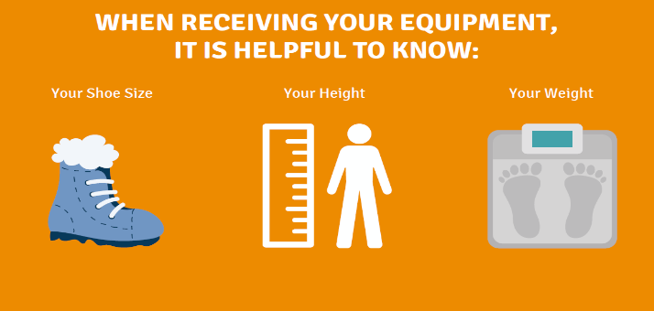
Please share this information with your classroom teacher so that they can ensure that your child is prepared and ready to go:

Shoe Size:________________________
Height:__________________________
Weight:__________________________

